NAME: SALEHA RAFIQUE
SAP ID: 49316
TASK 1

cat filename > new
This command reads the contents of filename and writes them into new.
If new already exists, its contents are overwritten.
If new does not exist, it is created.
who > new
This command lists the currently logged-in users and writes (overwrites) the output into new.
If new was created or had previous content, that content is lost.
ls | sort -r
The ls command lists the files and directories in the current directory.
The | (pipe) sends this output to sort -r, which sorts it in reverse order.
The sorted list is displayed on the terminal.
ls | sort -r >> new
Similar to the previous command, this sorts the directory listing in reverse order.
>> new appends this sorted output to new, without deleting existing content.
Task 2 :
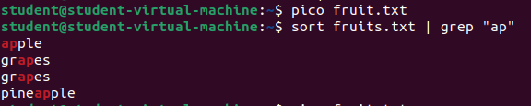
sort fruits.txt sorts the contents alphabetically.
| (pipe) sends this sorted output to grep "ap", which filters and displays only lines containing "ap".

Task 3:
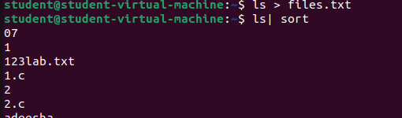
Streams, Redirection, and Pipes in Ubuntu
Streams

Streams are data flows used in Linux. The three standard streams are:
Standard Input (stdin) - 0: Takes input from the keyboard.
Standard Output (stdout) - 1: Displays output on the screen.
Standard Error (stderr) - 2: Displays error messages.
Example:
echo "Hello, World!"
This prints "Hello, World!" to stdout.
Redirection (>, >>)

Used to redirect input/output to files instead of the terminal.
Example:
ls > files.txt
This stores the output of ls into files.txt instead of displaying it on the terminal.
Pipes (|)

Used to connect multiple commands by passing the output of one as input to another.
Example:
ls | sort
This lists files and sorts them before displaying the output.

